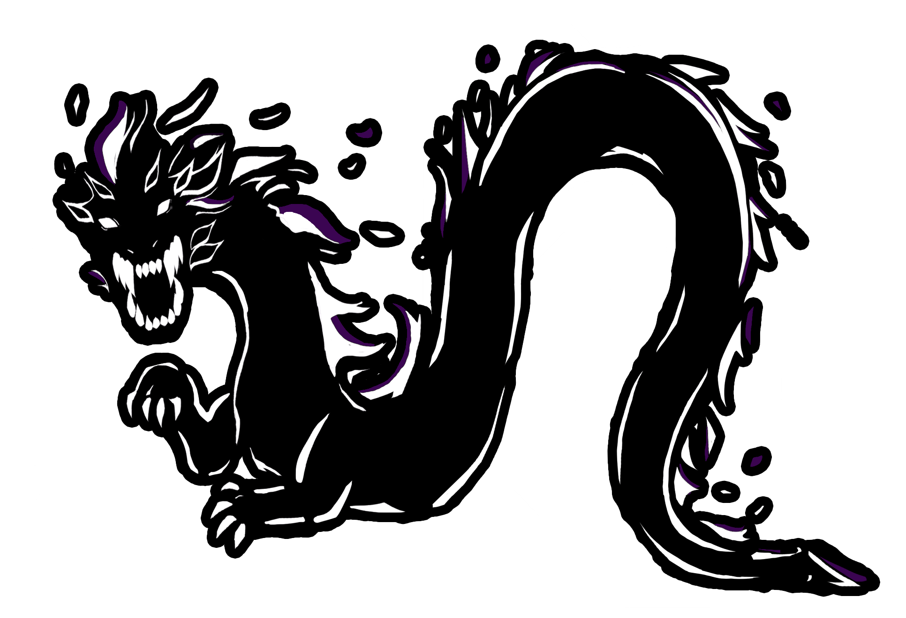

***(PHOENIX REMIX)***

REMIX!!

Hold up! Wait a minute!  
Shake your feathers

like a phoenix!

*(right)* Pho-pho-pho-phoenix!  
*(left)* Re-re-re-remix!

***Power Cheer***

**\*while stomping/clapping\***

Aaa-ahhh! A-Tech!!

Aaa-ahhh! A-Tech!!

***A-What!?***

**Leader:** A-What!? **Group:** A-Tech!

**Leader:** A-What!? **Group:** A-Tech!

A-Tech Key Club

RTC 2013 Cheers

***(CNH REMIX)***

REMIX!!

Hold up! Wait a minute!  
Let me put some booty in it!  
UNH! Some booty!

UNH! Some booty!

**GENERAL CHEERS**

***How Do You Feel!?***

**Leader:**

Hey Key Club!

How do you feel?

**Group:**

We feel good!

Oh, we feel so good, UNH!

We feel fine! All of the time!

Unga! Unga! Unga-Unga-Unga!

**\*while spinning\***

***Attitude Check***

**Leader:** Key Club Attitude Check!

**Group:** We Love Key Club!

***Let Me See You Get Down***

**Leader:**

Hey Key Club!

Let me see you get down!

**Group:**

No way!

**Leader:**

Let me see you get down!

**Group:**

Okay!

D-O-W-N

That’s the way we get down, UNH!  *(x2)*

***We’ve Got Spirit***

We’ve got spirit, Yes we do!

We’ve got spirit, How ‘bout you!?

**\*other group replies**\*

We’ve got spirit, Yes we do!

We’ve got spirit, How ‘bout you!?

**\*first group replies\***

We’ve got spirit, Yes we do!

We’ve got spirit, MORE THAN YOU!!

***LTG Cheer***

L-O-V-E! We love... our LTG!  
**\*while making a <3 sign\***

**A-TECH CHEERS**

After each cheer, don’t forget to BEE LOUD!!

***A-Tech Dragons***

L-O-U. D-E-R.

That’s what A-Tech Mavericks are!

We got that spirit,

Deep down inside!

So bring it up!

Don’t let it hide!

Roll your body,

And move your feet!

Stand up everybody!

Catch that dragon beat!

(Now let me hear all my Mavericks say!)

A-A A A-A

A-A...-TECH!!

***Outta Our Minds***

A-T-A's back! **\*stomp\***  
Listen good 'cuz we're bumping this track!  
Get back; get back,  
You're blocking our way!  
A-Tech's here; you got something to say!?  
Stop right there; you're crossing our line!  
Tick, tick, tick, BOOM!  
Clock's out of time!  
**\*stomp* *clap\***  
We're out of our minds!  
**\*stomp* *clap\***  
We're out of our minds!  
**\*stomp* *clap\***  
We're out of our minds!  
Bump this track; we're out of our minds!

***Fire It Up***

A-Tech Dragons, we’re ready to say,

A-Tech Dragons, gonna rock your day,

We’re blazing, ignited; we can’t be beat!

You’ll be so scared; you’ll feel this heat!

Our hearts so big, our courage so high,

Community service: all day, all night!

*Nooowwwww…* stomp your feet! Like

**\*stomp\*** **\*clap\*** **\*stomp\*** **\*stomp\*** **\*clap\***

**\*stomp\*** **\*clap\*** **\*stomp\*** **\*stomp\*** **\*clap\***

A...-Tech’s got the beat!

You’re gonna feel... A-Tech’s heat!

Now stomp, stomp, stomp your feet!

Feel that beat running through your FEET!

**\*stomp\*** Whooo!

***Beast Cheer***

A-T... E-C-H *(3x)*

A-Tech’s here so you best don't hate!

‘cuz... we... are...

BEAST!! **\*stomp\***

...even from the east!

We are the... best!

...surely from the west!

We set... forth!

...rep’n 2-8 north!

(Alright, now let’s show ‘em the rest!)

LIKE BOOM!! **\*stomp\*** **\*powder clap\***

We're gonna rock this house!

LIKE BOOM!!! **\*stomp\*** **\*clap\***

We're gonna SHOUT SO LOUD!

LIKE BOOM!!!! **\*stomp\*** **\*clap\***

WE'RE GONNA KNOCK YOU OUT!

And that's what A-Tech’s all about!

Go A-Tech, Go A-Tech, GO!

Go A-Tech, Go A-Tech, GO!!

**\*confetti toss\***

***A-Tech Spirit***

They call us A-Tech! A!!

They wanna bee us! B!!

Can you see us!? C!!

Now better hear us,

Cheer, cheer, cheer!

*(pause)*

In service and spirit, we raise the bar,

Can’t touch us up; too high, too far,

We’re number one,

We’re more than proud, **\*salute\***

Hey Mavericks! Let’s show ‘em how loud!

Hear us roar; demand it more,

Dragons’ fire, take it higher!

A... T-E-C-H. *(x3)*

*(starts soft, then gets louder)*

BOOM!!